**PRE-LAB REPORT**

**Experiment No :** 08

**Name of The Experiment :** Experimental studies on Precision half wave and full wave rectifier.

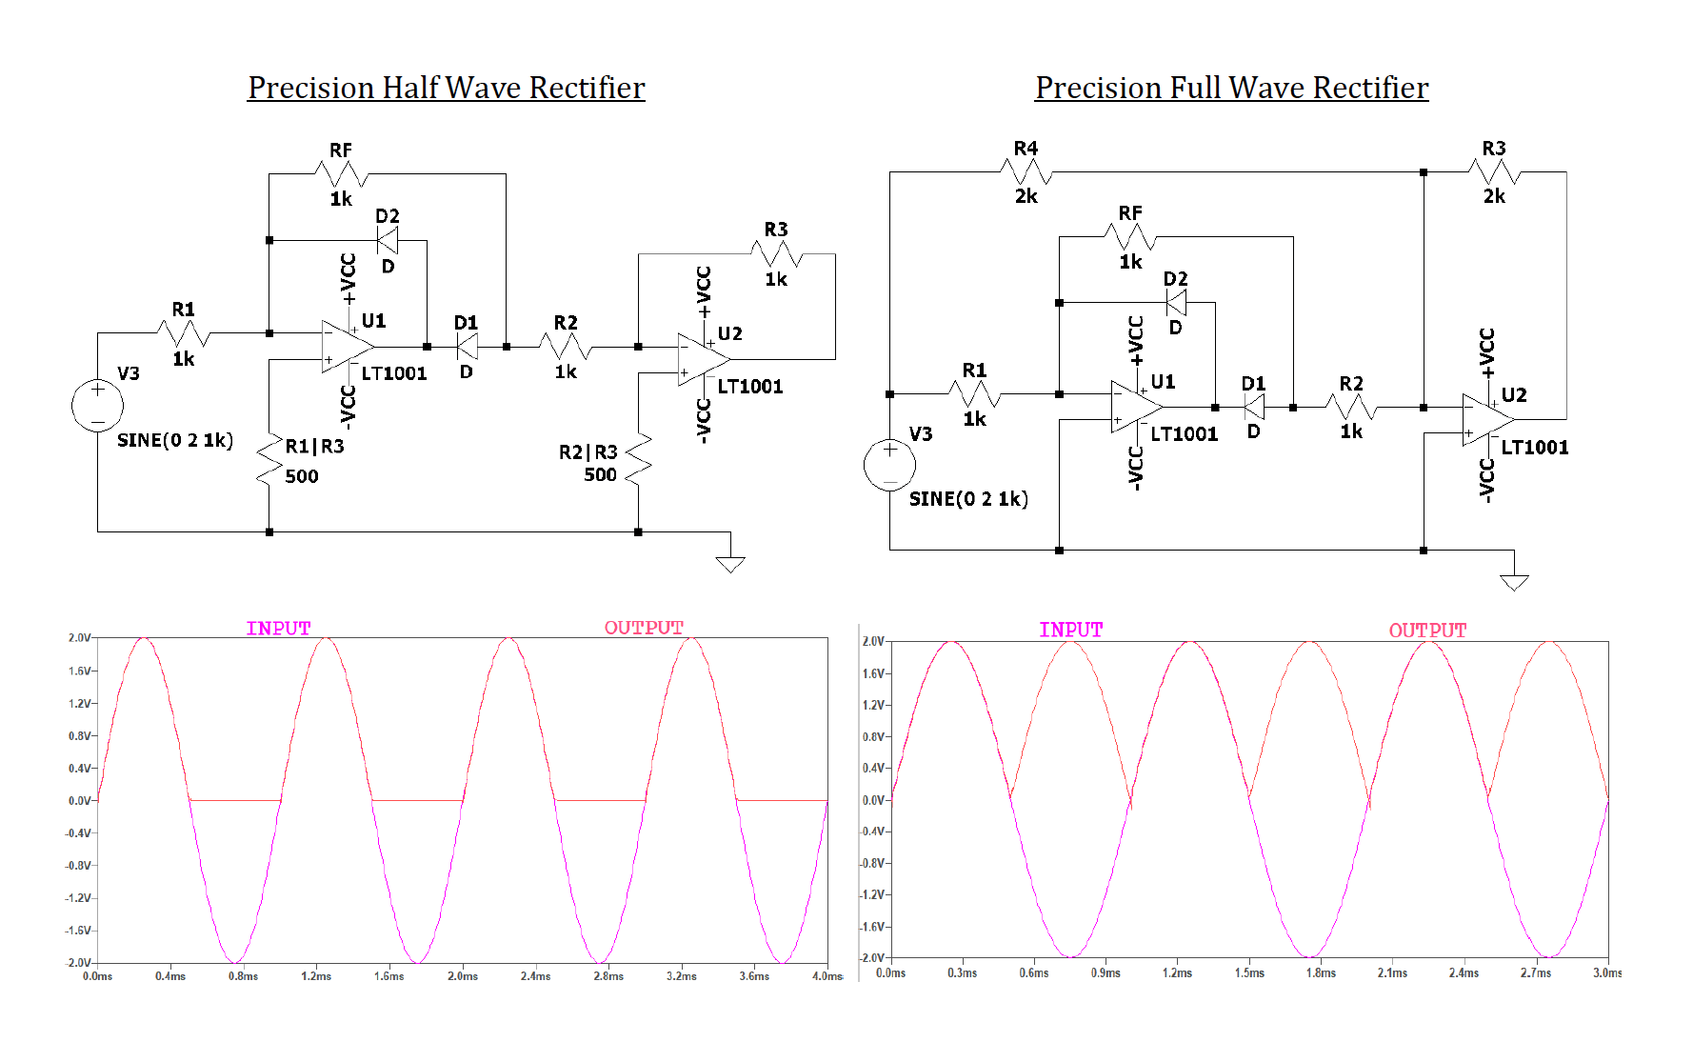**Circuit Diagram :**

**Fig – 01 :** Input-Output